SFY 2024-2025 Flood Infrastructure Fund  Abridged Application | Due 4/15/2024 at 11:59pm CDT  Email to FIF@twdb.texas.gov

By submitting this Abridged Application, you understand and confirm that the information provided is true and correct to the best of your knowledge and further understand that the failure to submit a complete Abridged Application by the stated deadlines, or to respond in a timely manner to additional requests for information, may result in the withdrawal of the Abridged Application without review. Please reference the SFY 2024-2025 Flood Infrastructure Fund (FIF) Intended Use Plan (IUP) for further explanation of all information and questions included herein.

General Information
Entity Name
Entity Type (City, County, District, etc.)

Primary Contact -  Who should TWDB contact with questions during the review of this submission? | Name
 | Title
 | Phone
 | Email

Project INFORMATION
Project Name (as Referred to by Applicant)
Regional Flood Planning Area (01-15)
Indicate Type: FME/FMP/FMS under 31 TAC § 361.10 (Only one type per abridged application) | ☐FME ☐FMP ☐FMS
Full Name of FME/FMP/FMS as presented in the Regional Flood Plan
Unique 9-digit FME/FMP/FMS ID (Example: 013000001) from the associated Regional Flood Plan
Is the geographic scope, project scope, and all the expected benefits of the project in this abridged application the same as those presented in the Regional Flood Plan? See the online link to review the associated project information and data.  FME List | FMP List | FMS List  Project scopes and claimed project benefits will be verified against the actual projects in the Regional Flood Plan during the application process. Any projects that are subsequently found to diverge from the information presented in this Abridged Application may be subject to reprioritization and/or removal from the prioritization list, regardless of their initial prioritization. Therefore, it is important that all project information be presented accurately in this abridged application. | ☐ YES ☐NO  If ‘NO’, please explain below why and generally explain how the project scope and/or benefits are different than what is presented in the Regional Flood Plan.  If ‘NO’, applicant must also fill in Attachment No. 3 with all project information including the items that are different compared to the information presented in the Regional Flood Plan.
NOTE: Regional flood planning data included in the draft FIF IUP materials, including associated with the abridged application, is not final and remains subject to change based on the final, Board-approved Regional Flood Plans.
NOTE: Abridged Applications submitted with partial projects from the regional flood plan will be considered ineligible for the FIF (except for phased projects).
FEDERAL AWARD MATCHING FUNDS
Requesting Federal Matching Award Funds? | ☐YES ☐NO
Name of Federal Grant Program
Date of Federal Application Submission
Date of actual or anticipated selection or award
NOTE: Federal application must have been submitted by Abridged Application submission date, and federal funds must be awarded by TWDB commitment date.

BUDGET DETAILS
Financing Requested from Federal Sources  - Federal Agency Name: Click or tap here to enter text.  - Disaster Number (if associated with disaster funding): Click or tap here to enter text. | $
Financing from Other Sources (Examples: All cash/loan/bond proceeds/non-federal grants, etc.) | $
Amount Requested from TWDB | $
Total Project Cost (Federal Funds + Other Sources + TWDB Request) | $

MINIMUM STANDARDS
Only projects that satisfy all minimum standards will be included in the prioritization. The numbered minimum standards reference the corresponding standard within the IUP.
CHECKLIST | MINIMUM STANDARDS
☐ | Regional Flood Plan  The project is specifically recommended in the corresponding Regional Flood Plan; the associated, unique, 9-digit ID and name has been provided; and any deviations in the benefits or geographic or other scope of the abridged application from the project that is presented in the Regional Flood Plan are noted, explained, and changed data provided in the associated Attachment No. 3.
☐  OR  ☐ | 1. Benefit/Cost Ratio (BCR)  For construction-oriented projects, including those with only planning, acquisition, and design (PAD) phases, the benefit-cost ratio (BCR) of the proposed project is ≥1.0, or the applicant must provide a detailed explanation for why the applicant considers the project to be justified, including a discussion of the primary benefits of the project, if any, that could not be quantified and were therefore not included in the BCR calculation. Please provide the following:  - A description of the BCA methodology (See example templates here, including the specific analysis tool and version used).  - Documentation of assumptions/parameters used to generate the BCA.  - A detailed BCA calculation. Applicant must provide all digital input files for BCA (e.g., Excel BCA Input Tool Run or additional calculations used in Excel or other formats)  - Identify and explain the responsible party for operation and maintenance (O&M) of the infrastructure and from what funding source O&M will be provided. O&M costs should be included within the BCA.  OR  N/A for FME Category, FMS Category, and potentially federal award matching fund projects (See the “Federal Award Matching Funds” section of the IUP for details).
☐  OR  ☐ | 2. Memorandum of Understanding (MOU)  If the project is a flood control project (as defined in 31 TAC § 363.402(3)), and the project watershed is partially located outside the political subdivision making the application, attach the following information:  - A list of all eligible political subdivisions that will be required to approve and sign an MOU (all eligible political subdivisions, as defined in the IUP, within the project watershed).  - A certification that the applicant has provided a copy of the proposed MOU and an adequately detailed description of the proposed project to all eligible political subdivisions on the list.  - PDF maps and GIS/KMZ files for all proposed project components and all boundaries for cities, districts, etc. within the proposed project watershed area.  OR  N/A for projects that are not flood control projects, including FMEs, or projects where the project watershed lies wholly within the applicant’s boundaries.
☐  AND  ☐ | 3. Affidavit  (a) The applicant has acted cooperatively with other political subdivisions to address flood control needs in the area in which the eligible political subdivisions are located; and all eligible political subdivisions substantially affected by the proposed flood project have participated in the process of developing the proposed flood project.  AND  (b) Applicant is aware of the affidavit requirements for the full/complete application and has or will fulfil all applicable requirements
☐ | 4. Redundant Funding  The funding request does not include redundant funding for activities already performed and/or funded through another source.
☐  OR  ☐ | 5. National Flood Insurance Program  (a) The area to be benefitted by the proposed project has floodplain management ordinances in place and the appropriate entity is currently enforcing floodplain management standards at least equivalent to the National Flood Insurance Program (NFIP) minimum standards.  OR  (b) Requesting funds to fulfill additional requirements for participation in the National Flood Insurance Program.
☐ | 6. Best/Most Recent Available Data  The proposed project was developed using the best and most recent available data.
☐  OR  ☐ | 7. Request for Constructions Funds  (a) Operations and maintenance (O&M) costs associated with proposed facilities have been considered; AND,  (b) Floodwater capture techniques have been considered.  OR  N/A for projects that are not requesting construction funds.
☐  OR  ☐ | Additional Requirements for Flood Management Evaluation (FME) Category  Applicant is aware that prior to the complete application, but not prior to the submittal of the abridged application, applicants must notify all cities, counties, non-profit water supply corporations, regional planning agencies, regional water planning groups, and all districts and authorities created under the Texas Constitution, Article III, Chapter 52, or Article XVI, Chapter 59, in the planning area by certified mail that an application for planning assistance is being filed with the TWDB.  OR  N/A for projects that do not fall within the Flood Management Evaluation (FME) Category.
☐  OR  ☐ | Additional Requirements for Flood Management Strategy (FMS) Category  The following is required in the abridged application for FMS Category non-study funding applications, which include construction-oriented projects and implementation projects, such as regulatory changes, flood warning improvements, emergency action plans, and education campaigns:  - Detail of the current flood risk in the project area.  - Detail of the revised flood risk of the project area if the project is constructed/implemented.  - The level of protection (i.e., 4%, 2%, 1% annual chance storm events) provided by the proposed project must be reported, when possible. For example, some implementation projects (like regulatory changes) may have defined levels of protection, others (like education campaigns) may not.  The following is required in the abridged application for roadway construction-oriented projects:  - Roadway classification  - Traffic count  - Detour distances  - Accident data  - Inundation risk including depths and velocities during 50%, 10%, 4%, 2%, 1% and 0.2% annual chance storm events.  The following is required in the abridged application for Flood Early Warning Systems (FEWS) construction-oriented projects:  - Quantitative information on the population impacted.  OR  N/A for projects that do not fall within the Flood Management Strategy (FMS) Category.
Description of Proposed Project
Please be sure this description includes all major project components and clearly states what the project seeks to accomplish.
Information for Grant Funding - Provide information for the applicable level of grant funding.
Flood Management Evaluation (FME) Category:
Grant Qualifier | Applicant Response
What is the AMHI (weighted average based on population) of the project area?

If requesting grant funds that rely on a calculation of the AMHI, then attach the calculation of the weighted average amounts for the project area based on the applicable U.S. Census Bureau geographic areas, such as County, Place (City), Census Tract, or Block Group using the ACS data sources described in the IUP.
Flood Mitigation Project (FMP) and Flood Management Strategy (FMS) Categories:
Grant Qualifier | Applicant Response
What is the AMHI (weighted average based on population) of the project area?
If requesting grant funds that rely on a calculation of the AMHI, then attach the calculation of the weighted average amounts for the project area based on the applicable U.S. Census Bureau geographic areas, such as County, Place (City), Census Tract, or Block Group using the ACS data sources described in the IUP.
For consideration as a Rural Applicant:
Are you an eligible entity based on the definition below? If so, please identify the applicable category below or provide an explanation under (D):
(A) a nonprofit water supply or sewer service corporation created and operating under Chapter 67 of the Texas Water Code or a district or authority created under Section 52, Article III, or Section 59, Article XVI, Texas Constitution, no part of the service area of which is located in an urban area with a population of more than 50,000;
(B) a municipality:
(i) with a population of 10,000 or less; or
(ii) located wholly in a county in which no urban area has a population of more than 50,000;
(C) a county in which no urban area has a population of more than 50,000; or
(D) an entity that:
(i) is a nonprofit water supply or sewer service corporation created and operating under Chapter 67 of the Texas Water Code, a district or authority created under Section 52, Article III, or Section 59, Article XVI, Texas Constitution, a municipality, county, or other political subdivision of the state, or an interstate compact commission to which the state is a party; and
(ii) demonstrates in a manner satisfactory to the board that the entity is rural or the area to be served by the project is a wholly rural area despite not otherwise qualifying under Paragraph (A), (B), or (C).
For consideration as a Green or Nature-Based project:
What is the percentage of total project costs that are considered green or nature-based? The calculation must be attached.
Select Questions for Prioritization criteria
Criteria | Applicant Response
TIEBREAKER: Social Vulnerability Index (SVI) | Average SVI of benefitting area: Click or tap here to enter text.  Geographic basis:  ☐ Census Tracts ☐ Counties  Please attach a list of the selected geographies and an explanation of why they were selected.
Additional Information for the Flood Information Clearinghouse Committee
This form is not required for submittal of a SFY 2024-2025 FIF Abridged Application.
Responses to the following questions, along with other information included in this Abridged Application, will be shared with the Flood Information Clearinghouse Committee (FLICC). The FLICC is a cooperative effort between the TWDB, General Land Office (GLO), Texas Division of Emergency Management (TDEM), and other state and federal agencies that administer flood mitigation financial assistance programs. After review by the FLICC, the applicant may be advised on other available funding opportunities for this project and given instructions on how to apply to relevant programs.
Please visit the FLICC website for more information: www.texasfloodclearinghouse.org
 | Type of Assistance Requested (Check all that apply): | ☐ Low Interest Loan  ☐ Grant  ☐ Loan/Grant Combination  ☐ Local Match for Federal Funding
 | Is the application requesting funds for the local cost share of a federally funded project? If yes, what is the name of the program? | ☐ Yes, Name of program:  ☐No
 | Associated FEMA disaster name and number (if applicable).
 | County(ies) in which the project is located.
 | Does the applicant have an approved Hazard Mitigation Plan?
 | Is the community to be served by the project in good standing with the National Flood Insurance Program (NFIP)?
 | Will this project involve enlargement of a dam or levee beyond the original footprint of the structure that existed prior to a disaster event?
 | Will this project mitigate a repetitive or severe repetitive loss property?

Attachment CHECKLIST
Complete | N/A | Attachment Description
☐ | ☐ | Benefit-Cost Ratio – BCR required information (See “Minimum Standards”).
☐ | ☐ | Memorandum of Understanding – MOU required information (See “Minimum Standards” and Attachment No. 1).
☐ | ☐ | Maps – Maps detailing project or study area boundaries, all proposed project components, HUC12, and all boundaries for cities, districts, etc. within the proposed project watershed area (See “Minimum Standards”):  - FME Category: PDF maps and GIS files must be submitted.  - FMP Category: PDF maps and GIS/KMZ files must be submitted.  - FMS Category: PDF maps and GIS/KMZ files must be submitted.
☐ | ☐ | National Flood Insurance Program – A pdf copy of (or a link to) ordinances demonstrating the area to be primarily benefitted by the proposed project has floodplain ordinances in place at least equivalent to NFIP minimum standards (See “Minimum Standards”).
☐ | ☐ | National Flood Insurance Program – Certification on enforcing floodplain management standards for all applicable areas (See Attachment No. 1).
☐ | ☐ | Best/Most Recent Data – Documentation indicating the best/most recent data was used in the development of the proposed project (See “Minimum Standards”).
☐ | ☐ | Average Median Household Income – If requesting grant funds that rely on a calculation of the AMHI, then attach the calculation of the weighted average amounts for the project area based on the applicable U.S. Census Bureau geographic areas such as County, Place (City), Census Tract, or Block Group and the ACS data sources described in the IUP (See “Information for Grant Funding”).
☐ | ☐ | Social Vulnerability Index – List and explanation of geographies used to determine average SVI (See “Select Questions for Prioritization Criteria”).
☐ | ☐ | Federal Award Matching Funds Projects Only - Documentation of an existing federal award pending availability of local match or submission of application for federal award (See “Project Information”).
☐ | ☐ | Construction Projects Only – Description of the anticipated funding source for operations and maintenance costs (See “Minimum Standards”).
☐ | ☐ | Flood Management Strategy Category Only – Additional required information for FMS Category (See “Minimum Standards”).
☐ | ☐ | For Green or Nature-Based Projects Only – Documentation showing the calculation of the total project costs that are considered green or nature-based (See “Information for Grant Funding”).
☐ | ☐ | Optional Item – Additional Information for the Flood Information Clearinghouse Committee (FLICC) (See “Additional Information for the Flood Information Clearinghouse Committee”).

SUBMITTAL

I, ______________(Name), _______________(Title), as the designated authorized representative of the _________________(Entity), hereby approve and authorize the submission of this abridged application to the Texas Water Development Board. I certify that all information contained herein is true and correct to the best of my knowledge, that all minimum standards applicable at this stage of submission for the proposed project have been met, and that all required attachments have been included. I understand the failure to submit a complete abridged application by the stated deadlines may result in the withdrawal of the abridged application without review.

Attachment 1: CertificationS

Certification on MOUs  (See Minimum Standard No. 2)  If no MOUs will be required, check here: ☐ | I, __________________________________________________(Name),  serving as _____________________________________________________________(Title)  hereby certify that _____________________________________________________(Applicant)  has provided all eligible political subdivisions, that will be required to submit a Memorandum of Understanding, a copy of their proposed Memorandum of Understanding and an adequately detailed description of the proposed project.  __________________________________ ________________________  Signature Date

Certification on Enforcing Floodplain Management Standards  (See Minimum Standard No. 5)  Exception:  The only exception is an entity that is requesting FIF funding to fulfill additional requirements for participation in the National Flood Insurance Program. If this is the situation, check here: ☐ | I, ________________________________________________________(Name),  serving as ______________________________________________________(Title)  hereby certify that _____________________________________________________(Appropriate entity for area to be served by the project)  is currently enforcing floodplain management standards at least equivalent to National Flood Insurance Program (NFIP) minimum standards, but those may exceed the NFIP minimum standard.  _________________________________ _________________________  Signature Date

ATTACHMENT 2: Memorandum of Understanding Template
TEXAS WATER CODE SECTION 15.005 MEMORANDUM OF UNDERSTANDING
This is a Memorandum of Understanding (MOU) between the <<GOVERNING BODY>> of <<ENTITY A>> (the “<<ENTITY A>>”) and the <<GOVERNING BODY>> of <<ENTITY B>> (the “<<ENTITY B>>”). <<MAY INCLUDE ADDITIONAL GOVERNING BODIES/POLITICAL SUBDIVISIONS OR MAY DEVELOP INDIVIDUAL MOUs WITH EACH POLITICAL SUBDIVISION WITHIN THE WATERSHED (see instructions in FIF IUP)>>
WHEREAS, pursuant to Texas Water Code § 15.005 and 31 Texas Administrative Code § 363.408, if the Executive Administrator determines that an application has flood control as one of its purposes and that the watershed in which the project is located is partially located outside the political subdivision making the application, the applicant must submit a written memorandum of understanding relating to the management of the watershed in which the project is to be located, signed by all governing bodies of eligible political subdivisions located in the project watershed; and
WHEREAS, <<ENTITY A>> has filed an application with the Texas Water Development Board for funding a project that has flood control as one of its purposes; and
WHEREAS, <<ENTITY A>> has determined that the watershed in which the project is located is partially located outside of <<ENTITY A>> and within the jurisdiction of <<ENITY B>>; and
NOW THEREFORE, in consideration of the benefits to the <<APPLICABLE/NAME OF>> Watershed and the State of Texas, <<ENTITY A>> and <<ENTITY B>> agree to the following:
- <<ENTITY A>> will provide <<ANNUAL/QUARTERLY/MONTHLY>>progress updates to <<ENTITY B>> as the project develops and changes.
- <<ENTITY A>> will notify <<ENTITY B>> of any potential change in impacts to <<ENTITY B>> within the <<QUARTER/MONTH>> of the identified change.
- <<ENTITY B>> will provide constructive input to <<ENTITY A>> as the project develops and changes.
- <<ENTITY A>> and <<ENTITY B>> will work cooperatively for the management of the <<NAME OF WATERSHED>>.

_______________________________________________________________
<<Responsible Official for Entity A, including Title>>
<<Entity A>>
_______________________________________________________________
<<Responsible Official for Entity B>>
<<Entity B>>

ATTACHMENT 3: Updated Project Information for Consideration
The image below is a hyperlink.
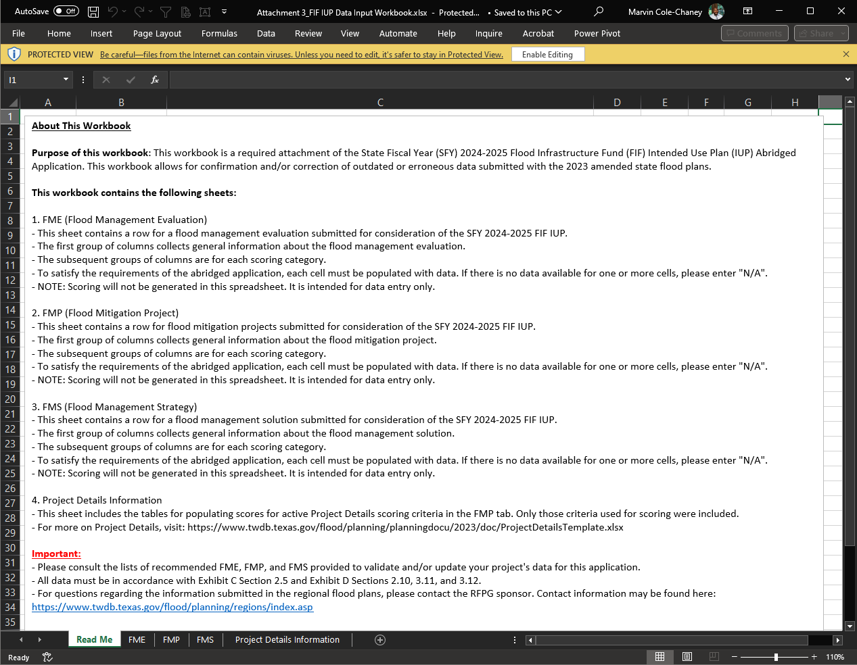

31 TAC § 361.10 Flood Management Evaluation (FME)--A proposed study to identify and assess and quantify flood risk or identify, evaluate, and recommend flood risk reduction solutions.
31 TAC § 361.10 Flood Mitigation Project (FMP)--A proposed project, both structural and non-structural, that has a non-zero capital costs or other non-recurring cost and that when implemented will reduce flood risk, mitigate flood hazards to life or property.
31 TAC § 361.10 Flood Management Strategy (FMS)--Flood risk reduction solution ideas and strategies that do not belong in FME or FMP categories. Examples may include regulatory enhancements, development of entity-wide buyout programs, and public outreach and education.

